Worksheet W.A.36.1
ANSWER SHEET

BINARY TREES

1. Given the following order of data from an input file, build the resulting ordered binary tree:

54 32 21 88 3 99 17 77 82 29 44 66

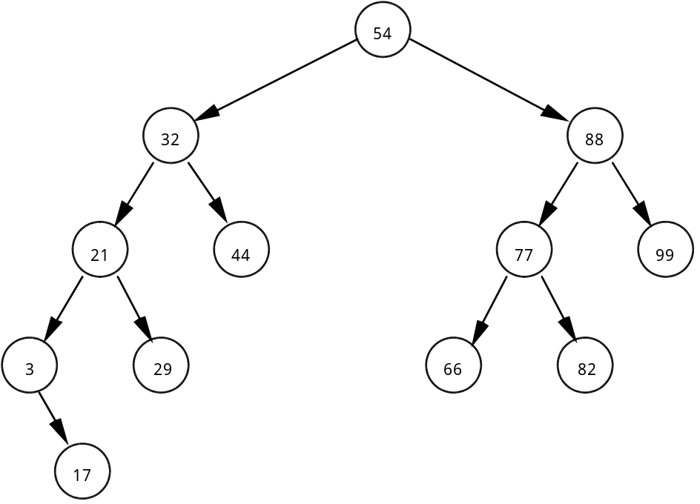

Define the following terms and describe examples from the above tree.

2. Parent - any node which has children, for example, the nodes with values 54, 32, 21,3, etc.

3. Child - any node which has a parent. All are children of some node except for the root node, the node containing value 54.

4. Root node - the node at the top of the tree; the node containing value 54.

5. Leaf - any node with zero children, for example, the nodes with values 17, 29, 44, 66, 82, 99.

6. Level - the distance of a node from the root node. The root node is considered to be level zero. The node with value 17 is in level 4, the node with value 66 is in level 3.

7. Subtree - an entire branch of a node, left or right. The left subtree of node with value 32 contains 4 values: 3, 17, 21, 29.

8. Edge - a segment which joins two nodes in the tree.

9. Explain how the order of the incoming data affects the shape of a binary tree. Use the back side to answer this problem.

If the data is already sorted in ascending or descending order, the resulting binary tree looks like a linked list. This is the worst case scenario for the construction of an ordered binary tree. For example, data coming in as

5 9 14 19 23 32 41

results in this shape tree:

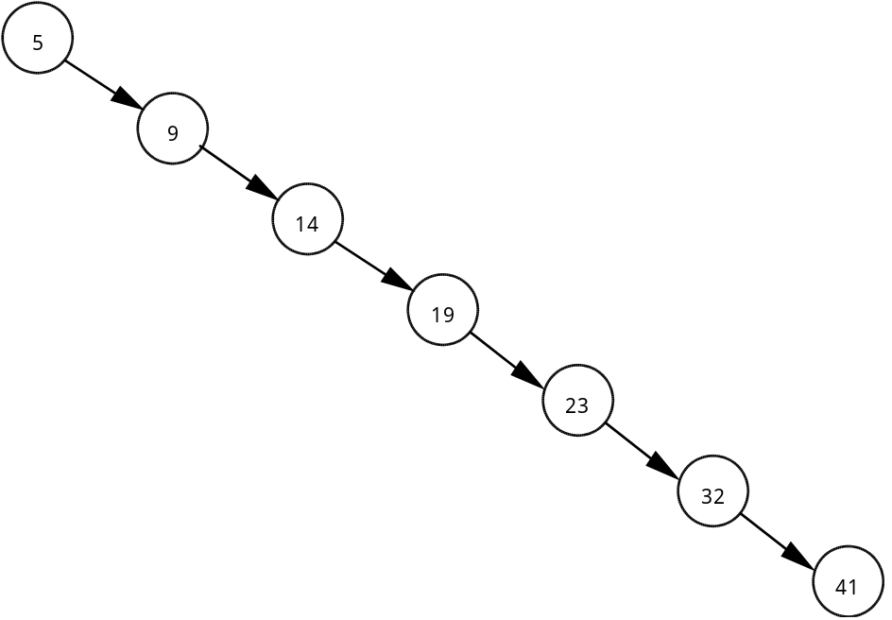

A random ordering of the data produces a more balanced tree such as the answer to Problem One. This results in a more efficient binary tree when it comes to inserting a new piece of data or searching the tree. The best case scenario is when the binary tree is balanced.

